✅ Recording Controller



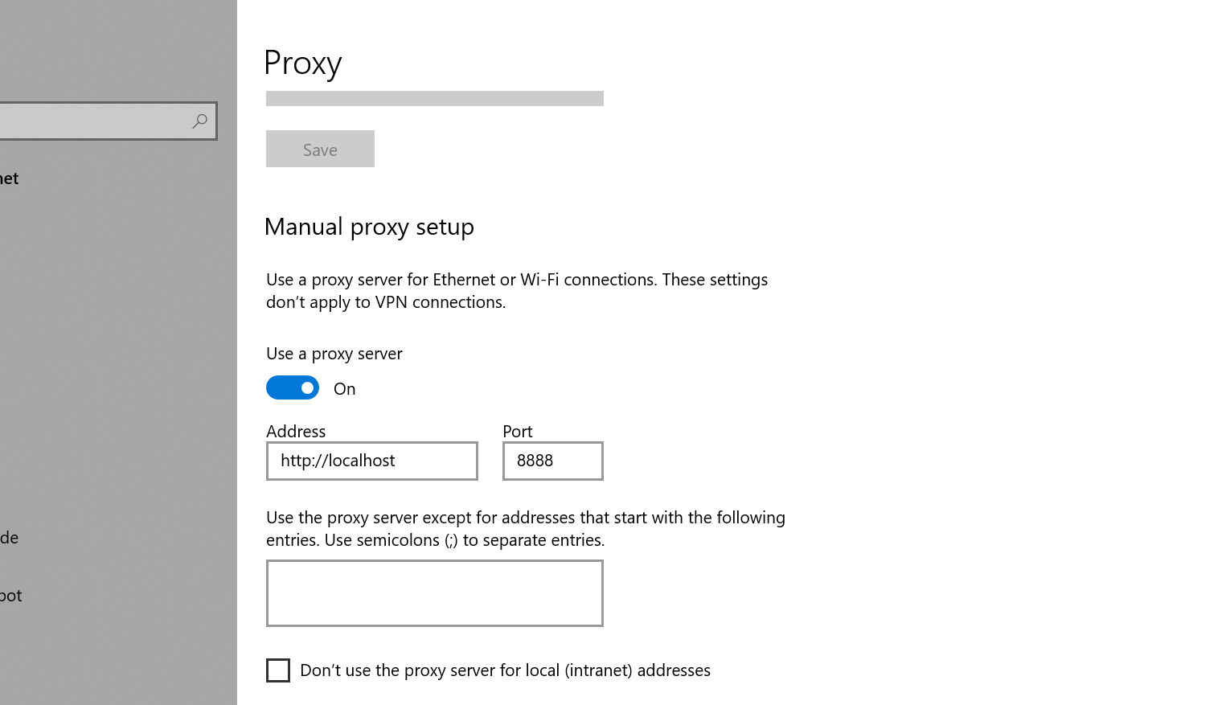

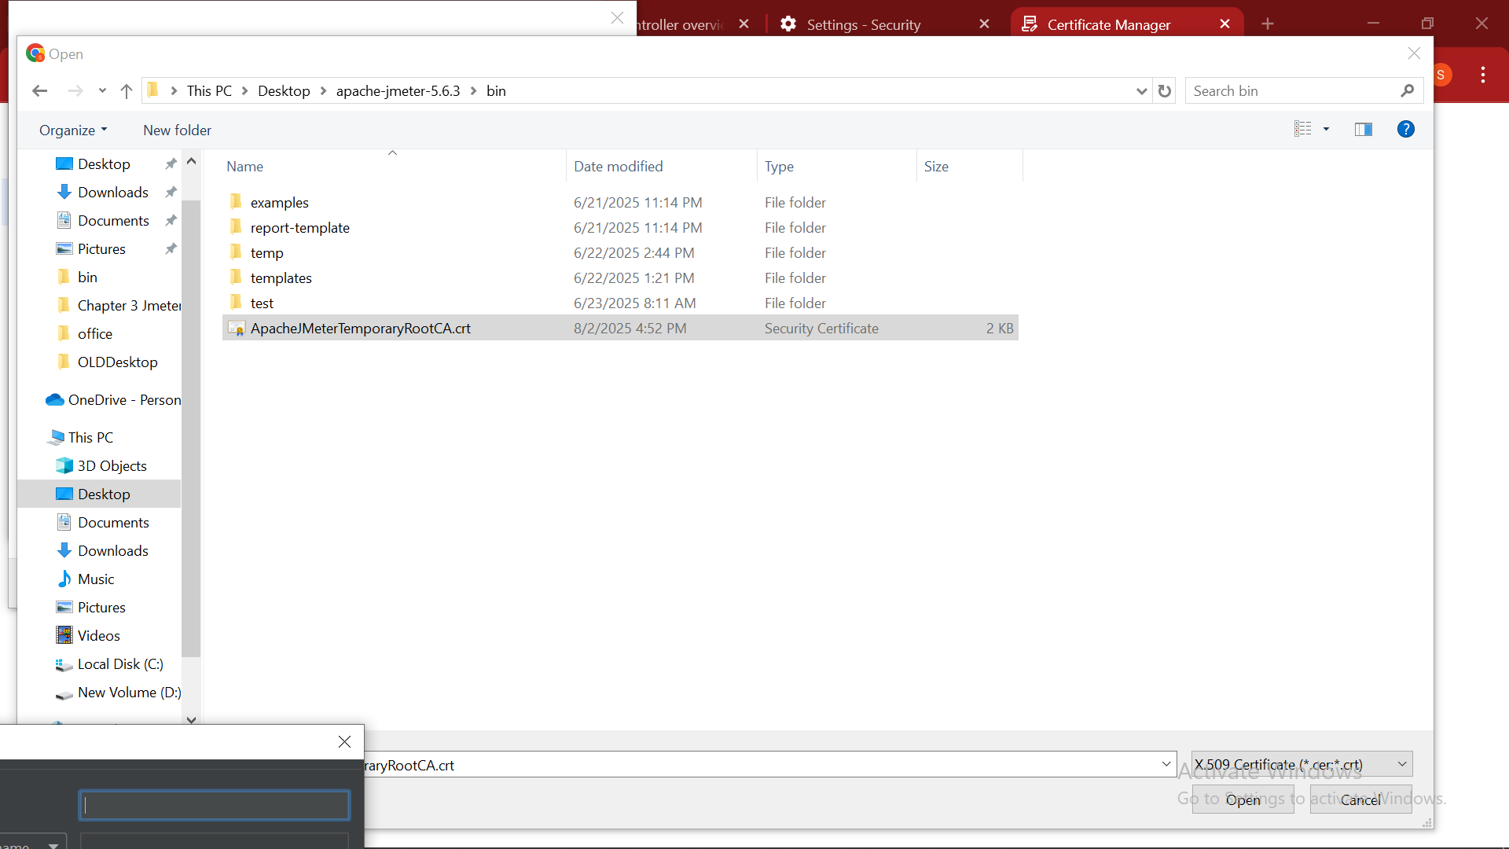

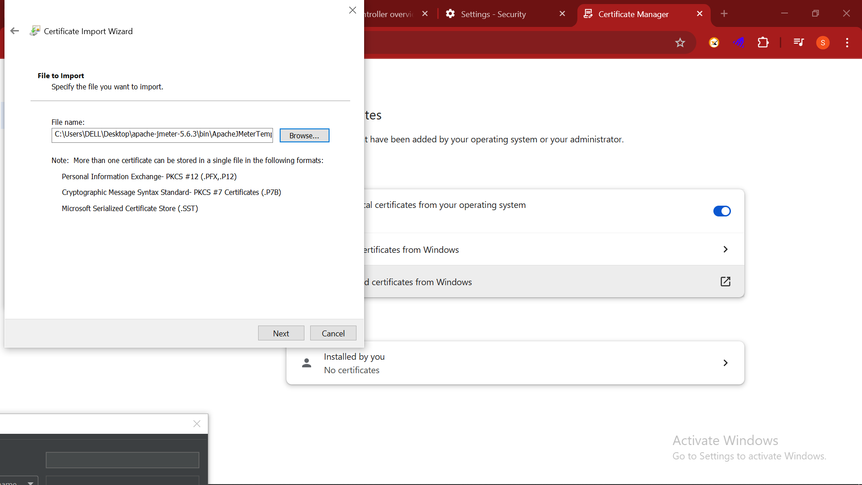

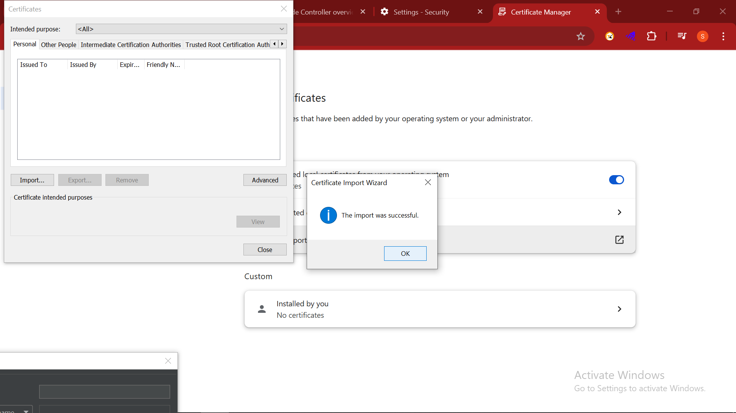

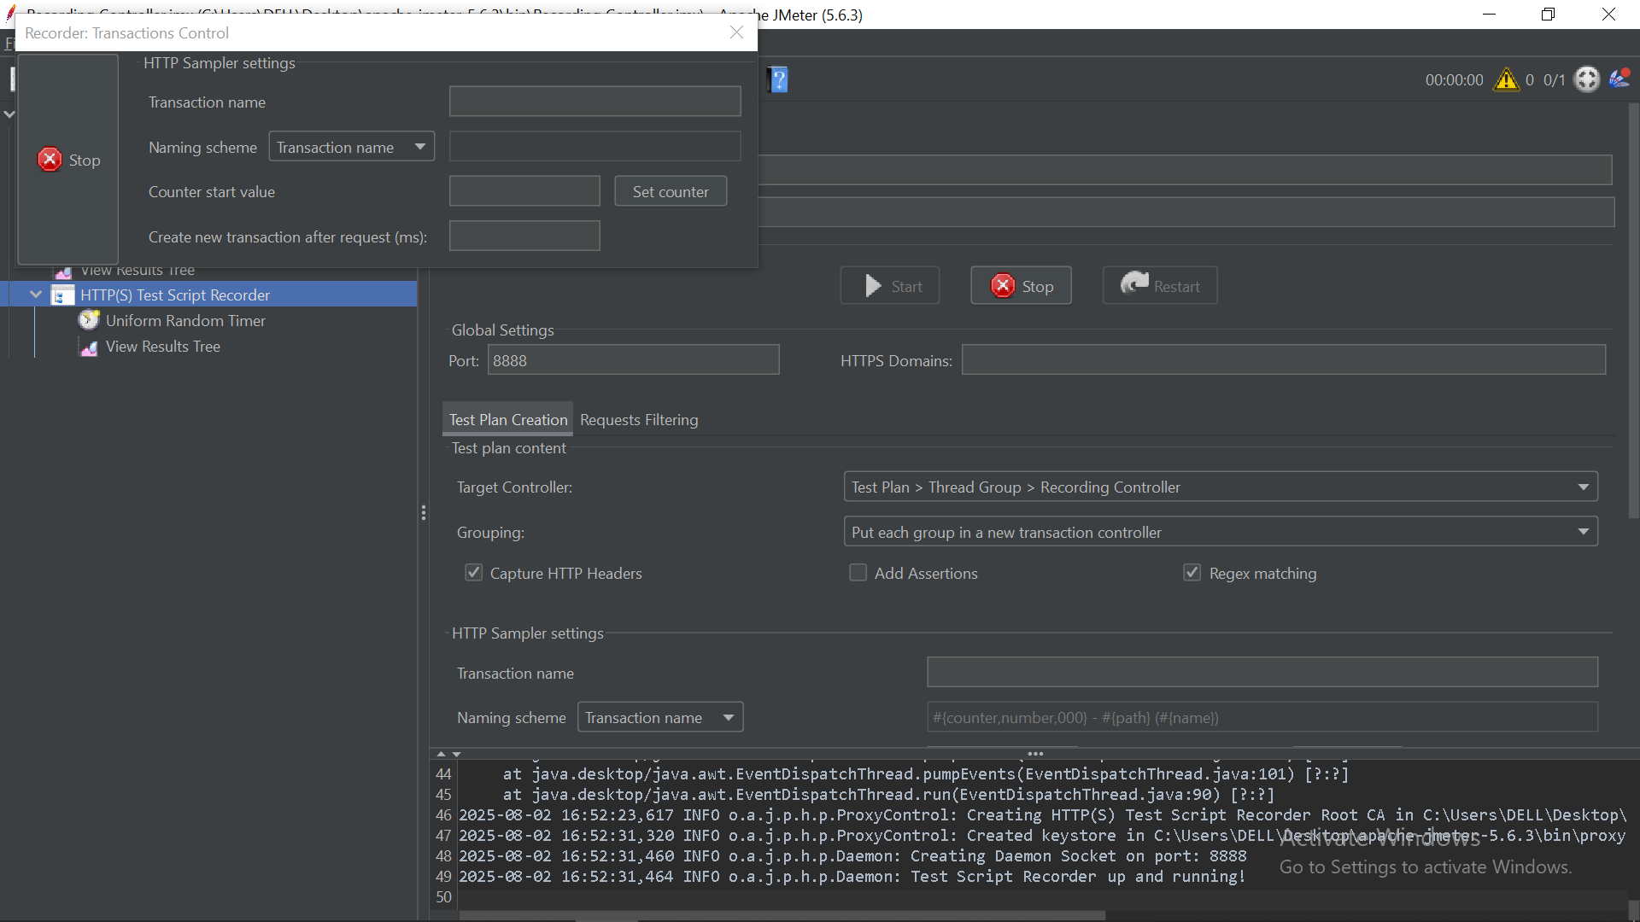

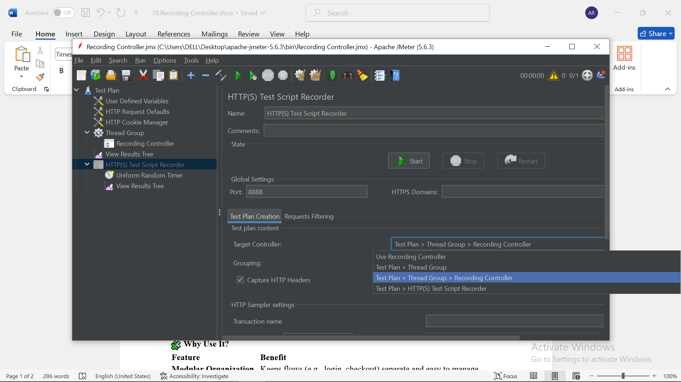

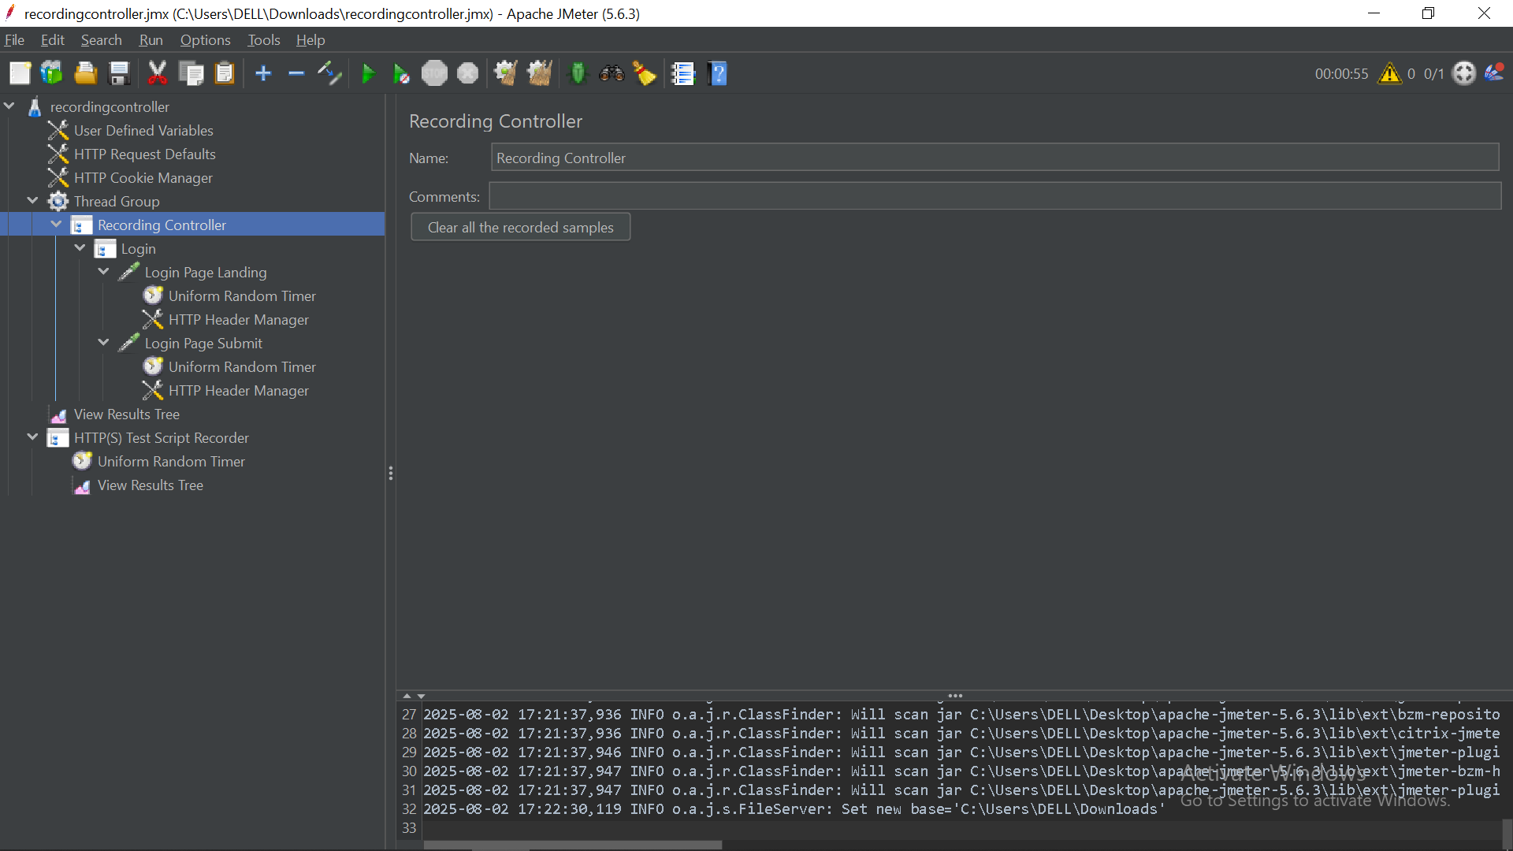

**🎯 Purpose**

The **Recording Controller** is a **Logic Controller** that acts as the **target container** for HTTP requests recorded by the **HTTP(S) Test Script Recorder**. It helps **organize** the recorded traffic instead of dumping everything into the Thread Group.

**🔧 How It Works**

1. **Create** a Recording Controller under a Thread Group.
2. **Configure** the HTTP(S) Test Script Recorder:
   * Set the **Target Controller** to your desired Recording Controller.
3. **Record** user actions:
   * Requests captured during recording are placed under the selected Recording Controller.
4. **Repeat** for different flows:
   * Create a new Recording Controller for each separate action (e.g., login, search, checkout).

**🧩 Why Use It?**

| **Feature** | **Benefit** |
| --- | --- |
| **Modular Organization** | Keeps flows (e.g., login, checkout) separate and easy to manage. |
| **Clean Structure** | Avoids cluttering the Thread Group with all HTTP Requests. |
| **Stepwise Recording** | Record flows individually for better clarity and control. |
| **Reusable** | Easily move to other controllers like Once Only, Transaction, etc. |

**📘 Best Practices**

* Always **name controllers meaningfully** (e.g., Login Flow, Search Product).
* Use **Transaction Controllers** around them post-recording to **measure timing**.
* Add **Assertions** and **Extractors** after recording for validation and dynamic data.
* **Record in phases**, using separate Recording Controllers for each phase.
* Don’t forget to configure **proxy settings** in the browser correctly.

**📂 Example Test Plan Structure**

pgsql

CopyEdit

Test Plan

└── Thread Group

├── Recording Controller (Login Flow)

│ ├── HTTP Request - Login Page

│ └── HTTP Request - Submit Credentials

├── Recording Controller (Product Search)

│ ├── HTTP Request - Search Page

│ └── HTTP Request - Search Results

If you'd like, I can also create a **visual diagram** or a **step-by-step checklist PDF** for your reference or training materials. Would you like that?

Ask ChatGPT